MATHEMATICS SPECIALIST

MAWA Year 12 Examination 2019

Calculator-assumed

Marking Key

© MAWA, 2019
Licence Agreement
This examination is Copyright but may be freely used within the school that purchases this licence.
- The items that are contained in this examination are to be used solely in the school for which they are purchased.
- They are not to be shared in any manner with a school which has not purchased their own licence.
- The items and the solutions/marking keys are to be kept confidentially and not copied or made available to anyone who is not a teacher at the school. Teachers may give feedback to students in the form of showing them how the work is marked but students are not to retain a copy of the paper or marking guide until the agreed release date stipulated in the purchasing agreement/licence.

The release date for this exam and marking scheme is 14th June.

Question 9(a) (3 marks)

Solution
If

Now has modulus and argument
Thus the two roots of the quadratic are cis with

Mathematical behaviours | Marks
- applies the quadratic formula appropriately  - identifies the modulus and argument for one of the roots  - deduces the second root | 1  1  1

Question 9(b) (3 marks)

Solution
Since then

If then

For this to hold, the argument must be a multiple of which implies that is a multiple of 3

Mathematical behaviours | Marks
- states the correct form for  - derives the correct equation for the two expressions to be equal  - deduces the acceptable values of | 1  1  1

Question 10(a) (3 marks)
Solution
If rij then and
Hence and . Since ,
Mathematical behaviours | Marks
- correctly determines equations for $\frac{x}{3}=cos⁡(2t)$ and $\frac{y}{4}=sin⁡(2t)$  - uses Pythagorean theorem correctly to obtain the result required | 2  1

Question 10(b) (1 mark)
Solution
The path is an ellipse
Mathematical behaviours | Marks
- states the path is an ellipse | 1

Question 10(c) (1 mark)
Solution
If rij then vij
Mathematical behaviours | Marks
- derives the correct expression for the velocity vector | 1

Question 10(d) (3 marks)
Solution
Speed =|v(t)|
This equals
 | Marks
- writes down the correct expression for the speed  - rewrites  - obtains an expression for the speed in terms of | 1  1  1

Question 10(e) (2 marks)
Solution
Maximum speed occurs when and then speed is

If for integer
Hence maximum speed attained when for integer values of

 | Marks
- deduces the maximum speed  - states the times when maximum speed is attained | 1  1

Question 11 (6 marks)

Solution
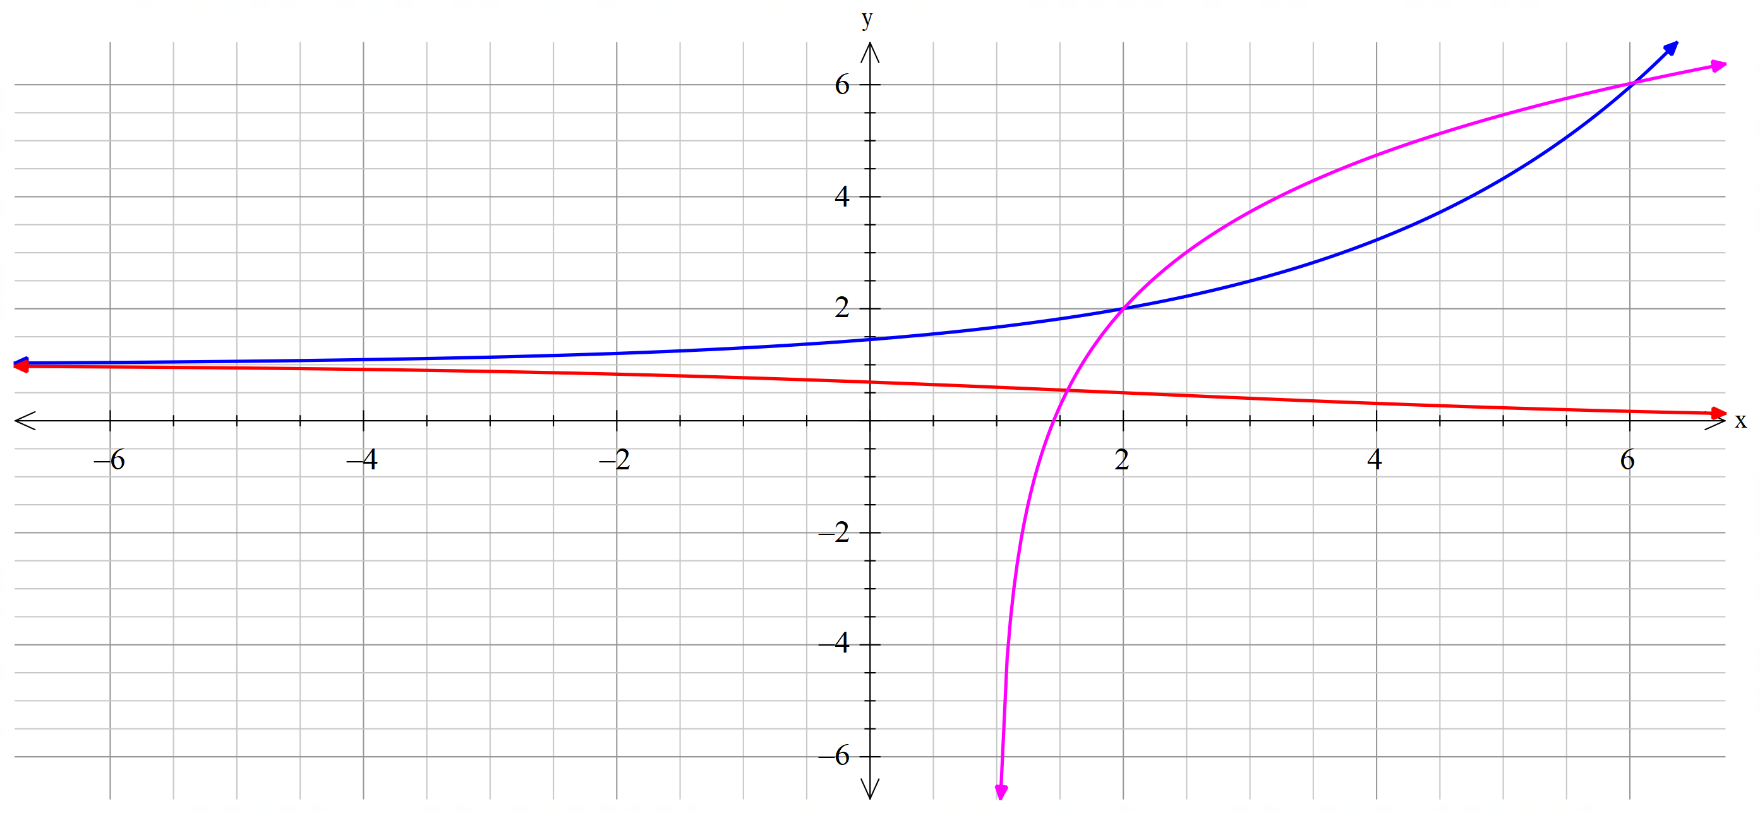

Mathematical behaviours | Marks
- displays correct shape of $y=1/f(x)$ graph  - indicates correct horizontal ‘limits’ of $1/f(x)$ graph  - displays ‘reflection’ property of $y=f^{-1}(x)$ graph in  - displays ‘intersection’ points near $(2,2)$ and $(6,6)$ | 1  1+1  1  1+1

Question 12 (8 marks)

Solution
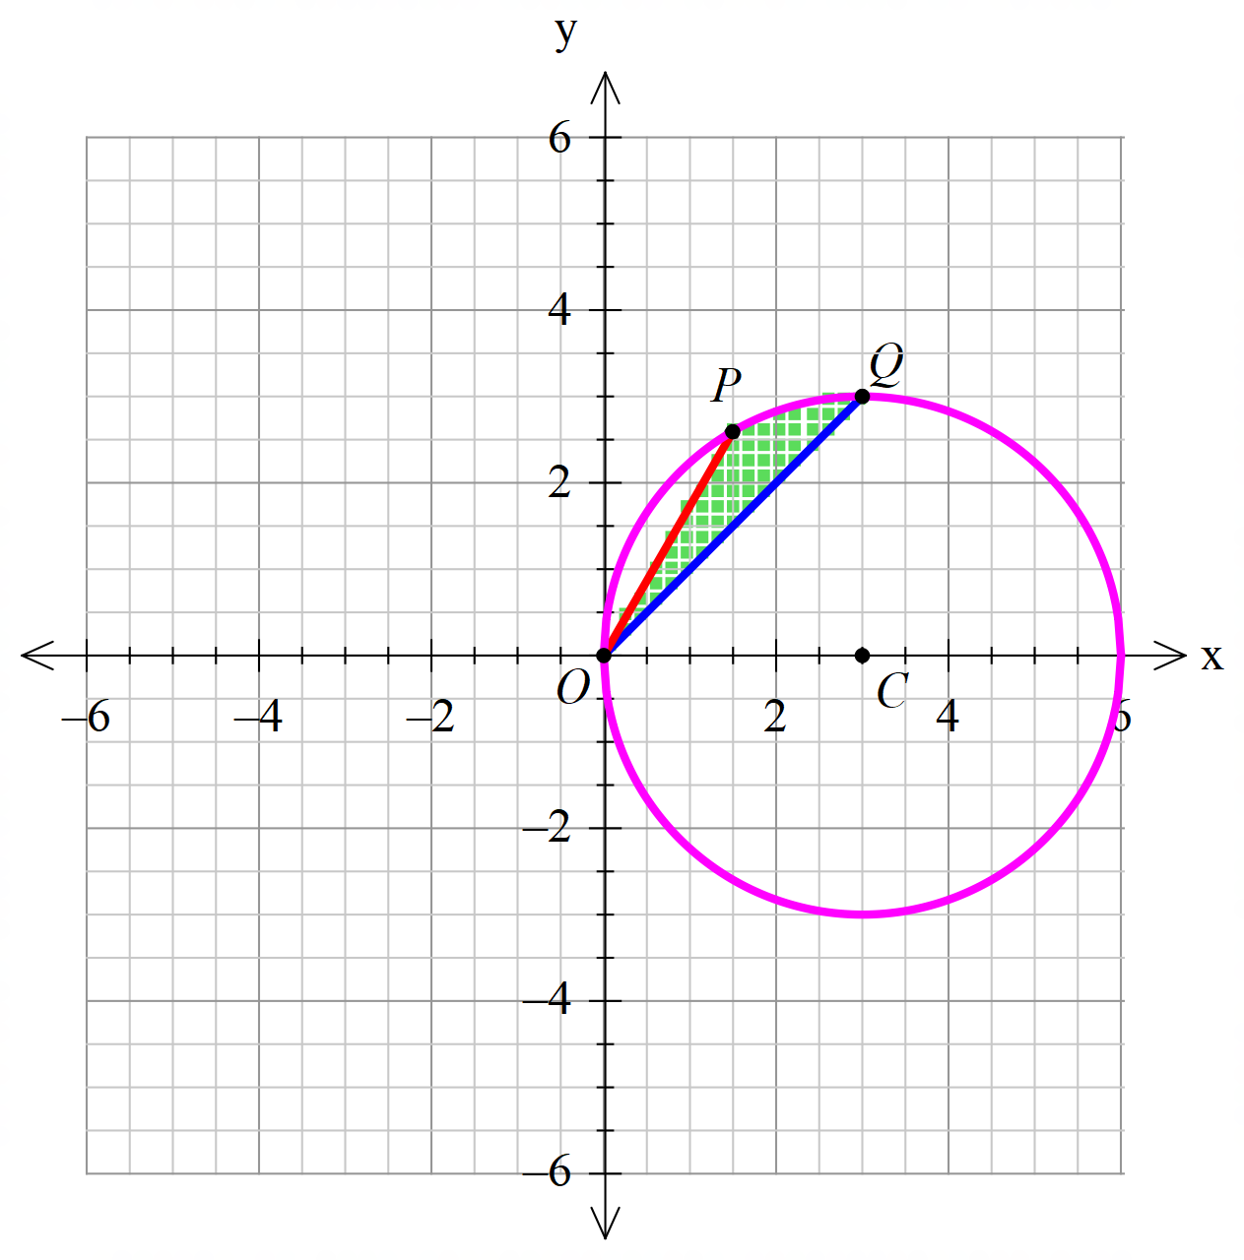

As OC=CQ and angles ; hence so co-ordinates of Q are (3,3)

Also anglesand since the triangle OPC is equilateral. Hence x co-ordinate of P is so that co-ordinates of P are
Area includes the boundary

Mathematical behaviours | Marks
- draws the circle with correct centre and correct radius  - draws lines of appropriate slopes through the origin  - shades (or somehow indicates) the required area  - derives the co-ordinates of Q  - derives the co-ordinates of P  - makes statement or shows that the boundary is included in region | 1+1  1  1  1  1+1  1

Question 13 (a) (7 marks)
Solution
Initial velocity vi + j =( i+ j)
As aj then vj j+ c
Applying the initial condition yields c=( i+ j) so vi j

Integrating again then
rvi j + d for some constant d
Since initially r=0 so d=0, and hence

ri j

Mathematical behaviours | Marks
- correctly obtains v(0)  - uses aj to derive v  - uses initial conditions to determine the constant vector c  - deduces that vi j  - anti-differentiates v to give r  - uses r0 to determine d  - deduces the final form of r | 1  1  1  1  1  1  1

Question 13 (b) (2 marks)
Solution
Maximum height is achieved when the vertical component of velocity vanishes
This occurs when
At this time height of projectile is
metres
Mathematical behaviours | Marks
- determines time for maximum height  - correctly evaluates for maximum height of 500 m | 1  1

Question 13 (c) (2 marks)
Solution
Projectile reaches horizontal again when the j component of r vanishes.
The requisite time is seconds
 | Marks
- recognition of the need to determine when the vertical displacement is zero  - correct calculation of total flight time | 1  1

Question 13 (d) (2 marks)
Solution
When then v(i - j) and speed = m/s

 | Marks
- evaluation of the velocity vector when the projectile strikes ground  - evaluates the requisite speed | 1  1

Question 14 (a) (7 marks)
Solution
Since , .But this quadratic has no real roots so has no real zero.

Now
.

Hence at and .
Since and , then and are critical points.
The line is a vertical asymptote for the graph.
As
then as

Mathematical behaviours | Marks
- shows that there is no zero  - differentiates correctly  - solves $f^{'}\left(0\right)=0$  - evaluates $f(1)$ and $f(3)$  - obtains vertical asymptote  - derives the correct form of the expression for large  - deduces correct limiting behaviours as $x→∞$ and $x→-∞$ | 1  1  1  1  1  1  1+1

Question 14 (b) (5 marks)
Solution
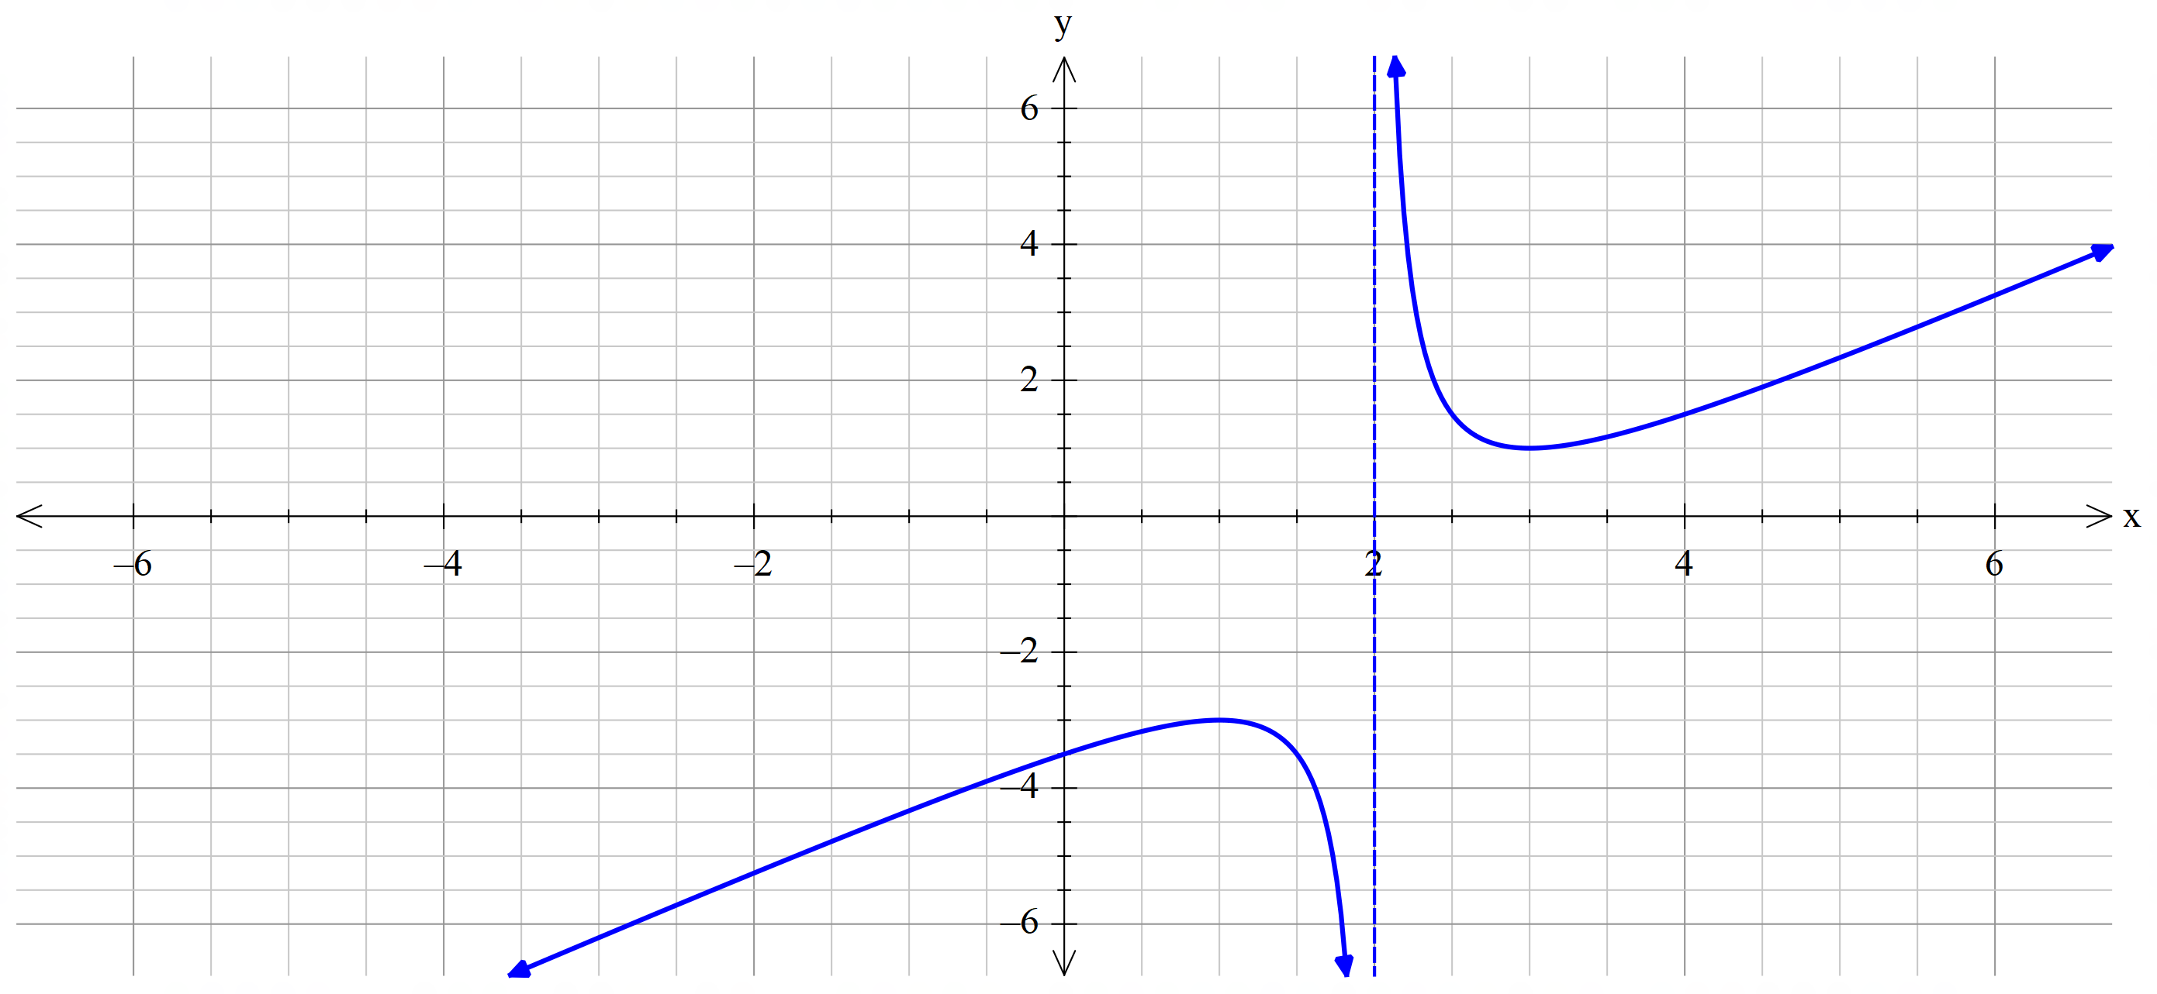

Mathematical behaviours | Marks
- shows vertical asymptote correctly  - shows critical points correctly  - indicates where the curve cuts the y-axis  - displays oblique asymptote correctly | 1  1+1  1  1

Question 15(a) (3 marks)

Solution
We know that so that
Then
so that
as required.

Mathematical behaviours | Marks
- writes down appropriate form for  - uses appropriate properties to write this exponential in terms of and  - deduces the requisite result | 1  1  1

Question 15(b) (6 marks)

Solution
If we denote

Raising to the appropriate power gives

Hence
so that
as required

Mathematical behaviours | Marks
- raises the result of part (a) to the fifth power  - expands the binomial correctly (both coefficients and signs)  - collects powers together in the appropriate way  - writes in terms of  - deduces the required answer | 1  1+1  1  1  1

Question 16(a) (6 marks)

Solution
If is a factor of then this means that

Hence ………….(*)

Equating imaginary parts tells us that

Now this gives that either or

The real part of (*) gives that

Now if this equation cannot hold so this possibility must be ruled out.

Then if

Hence we conclude that and

Mathematical behaviours | Marks
- appreciates that is a factor implies that  - expands the form of  - puts real and imaginary parts of the expression both equal to zero  - shows that imaginary part yields three possible values for  - argues that the form of the real part prohibits the possibility  - hence deduces the appropriate value of | 1  1  1  1  1  1

Question 16(b) (4 marks)

Solution
Now we deduce that is a factor of
By long division or CAS
If

Hence the four roots of are and

Mathematical behaviours | Marks
- identifies the quadratic factor of  - determines the other quadratic factor  - solves for the other two roots of the equation  - states all four solutions in explicit form | 1  1  1  1
Question 17 (a) (3 marks)
Solution
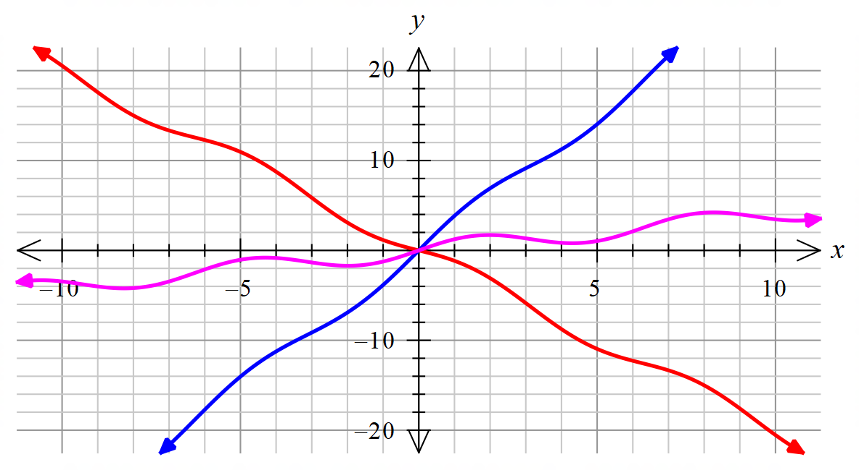

Mathematical behaviours | Marks
- plots the three graphs reasonably accurately  (blue curve is , purple and red ) | 1+1+1

Question 17(b) (4 marks)
Solution
$$f^{'}\left(x\right)=A+\cos{x}$$
So $A-1≤f^{'}\left(x\right)≤A+1.$
Now $f$ is $1-1↔f'$ does no change sign. (*)
So $f$ is $1-1↔A≥1$ or $A≤-1$
Mathematical behaviours | Marks
- differentiates correctly  - notes the range of values of the derivative  - identifies criterion for $1-1$ property (*)  - answers correctly | 1  1  1  1

Question 17(c) (3 marks)
Solution
To evaluate $f^{-1}(5)$ we need to solve $f\left(x\right)=-2x+\sin{x}=5$ (*)
From a calculator $x≅-2.71$
Mathematical behaviours | Marks
- writes down equation (*)  - gives solution to the specified level of accuracy | 1  2

Question 18 (a) (6 marks)
Solution
Let A denote the airplane.
Given the position and velocity in the question, at time after 1pm the airplane is located at

Similarly, at the same time the helicopter is located at

The first components of the two position vectors coincide when

When the aircraft is located at

The helicopter is located at

Mathematical behaviours | Marks
- correctly determines the position of the airplane at time  - correctly determines the position of the helicopter at time  - determines when one the components of the two locations are equal  - shows that at this time the other two components are also equal  - concludes with evidence that a collision is imminent | 1  1  2  1  1

Question 18 (b) (2 marks)
Solution
Since the collision occurs at 3.36pm and at the location ijk

Mathematical behaviours | Marks
- correctly converts $t=2.6$ to 3.36 p.m.  - states position of the collision point | 1  1

Question 18 (c) (7 marks)
Solution
At 2 p.m., $t=1$ so

$r_{A}\left(1\right)= <60, 160, 3.74>+1<-100, 20, 0.8> = <-40, 180, 4.54>km$ and

$$r_{H}\left(1\right)= <-70, 108, 4.52>+1<-50, 40, 0.5> = <-120, 148, 5.02>km$$

Making the helicopter to be at rest (by imposing a negative velocity on it) we have:
$$_{A}v_{H}=v_{A}-v_{H}=<-150, 120, 0.5> - <-50, 40, 0.5> = <-100, 80, 0>$$
$$\vec{HA}=\vec{HO}+\vec{OA}= -<-120, 148, 5.02>+ <-40, 180, 4.54> = <80, 32, -0.48>$$

$\vec{HR}=\vec{HA}+ _{A}v_{H}$ (where R is the point at which airplane and helicopter are closest)
$=<80, 32, -0.48>+ t<-100, 80, 0>$
$$= <80-100t, 32+80t, -0.48>$$

Calculate $\vec{HR} ∙$ $_{A}v_{H}=0$ to determine closest distance between aircraft
i.e. $<80-100t, 32+80t, -0.48> ∙ <-100, 80, 0> =0$

Simplifying gives: $5440=16400t →t=0.3317$ hours

At $t=0.3317$ , $\left|\vec{HR}\right|=\left|<46.83, 58.536, -0.48>\right|=74.96$km

$∴$ the shortest distance between the aircraft following the redirection is 74.96 km

Mathematical behaviours | Marks
- determines the position vectors $r_{A}\left(1\right)$ and $r_{H}\left(1\right)$  - determines relative velocity vector for $_{A}v_{H}$  - correctly develops equation (i.e. $\vec{HR}=\vec{HA}+ _{A}v_{H}$)  - uses scalar dot product $\vec{HR} ∙$ $_{A}v_{H}=0$  - evaluates for $t=0.7508$ hours  - determines minimum distance following the redirection | 2  1  1  1  1  1

